# Lab 4

## By

## Saad Azhar

## Reg # 120071

## BSCS-5C

Github Link:

<https://github.com/SaadAzhar/AirPassengersAnalysis>

# Task1:

a <- matrix(AirPassengers, nrow=12) #Original data in transposed matrix

b <- t(a) #Original data matrix

colnames(b) <- c("Jan", "Feb", "Mar", "Apr", "May", "Jun", "Jul", "Aug", "Sep", "Oct", "Nov", "Dec")

rownames(b) <- c("1949", "1950", "1951", "1952", "1953", "1954", "1955", "1956", "1957", "1958", "1959", "1960")

colMax = colnames(b)[which(b == max(b), arr.ind=TRUE)[,2]] #Get max month and year

rowMax = rownames(b)[which(b == max(b), arr.ind=TRUE)[,1]] #Get max month and year

cat("The max monthly profit was generated in",colMax, rowMax)

colnames(a) <- c("1949", "1950", "1951", "1952", "1953", "1954", "1955", "1956", "1957", "1958", "1959", "1960")

c <- (apply(a, 2, cumsum))

yearMax = colnames(c)[which(c == max(c), arr.ind=TRUE)[,2]] #Get max year

cat("The max yearly profit was generated in",yearMax)

ts.plot(AirPassengers)

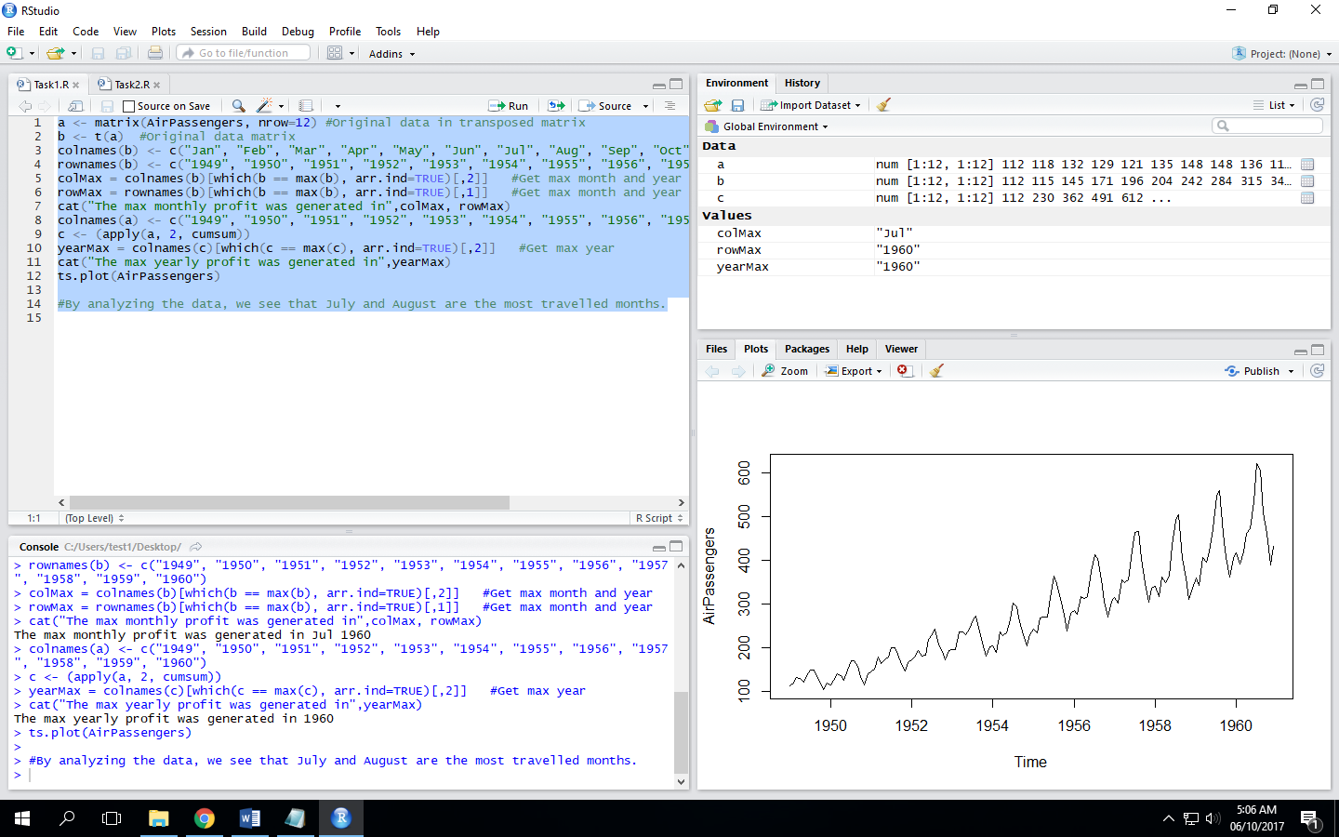

# Task 2:

a <- matrix(AirPassengers, nrow=12) #Original data in transposed matrix

b <- t(a) #Original data matrix

price = 8000

for(x in 1:12){

for(y in 1:12){

newMat = b*price #Loop for calculating the matrix to be used in this task

}

price = price*1.1

}

colnames(newMat) <- c("Jan", "Feb", "Mar", "Apr", "May", "Jun", "Jul", "Aug", "Sep", "Oct", "Nov", "Dec")

rownames(newMat) <- c("1949", "1950", "1951", "1952", "1953", "1954", "1955", "1956", "1957", "1958", "1959", "1960")

colMax = colnames(newMat)[which(newMat == max(newMat), arr.ind=TRUE)[,2]] #Get max month and year

rowMax = rownames(newMat)[which(newMat == max(newMat), arr.ind=TRUE)[,1]] #Get max month and year

cat("The max monthly revenue was generated in",colMax, rowMax)

colnames(newMat) <- c("1949", "1950", "1951", "1952", "1953", "1954", "1955", "1956", "1957", "1958", "1959", "1960")

c <- (apply(newMat, 2, cumsum))

yearMax = colnames(c)[which(c == max(c), arr.ind=TRUE)[,1]] #Get max year

cat("The max yearly revenue was generated in", yearMax)

cat("The total revenue generated:", sum(newMat))

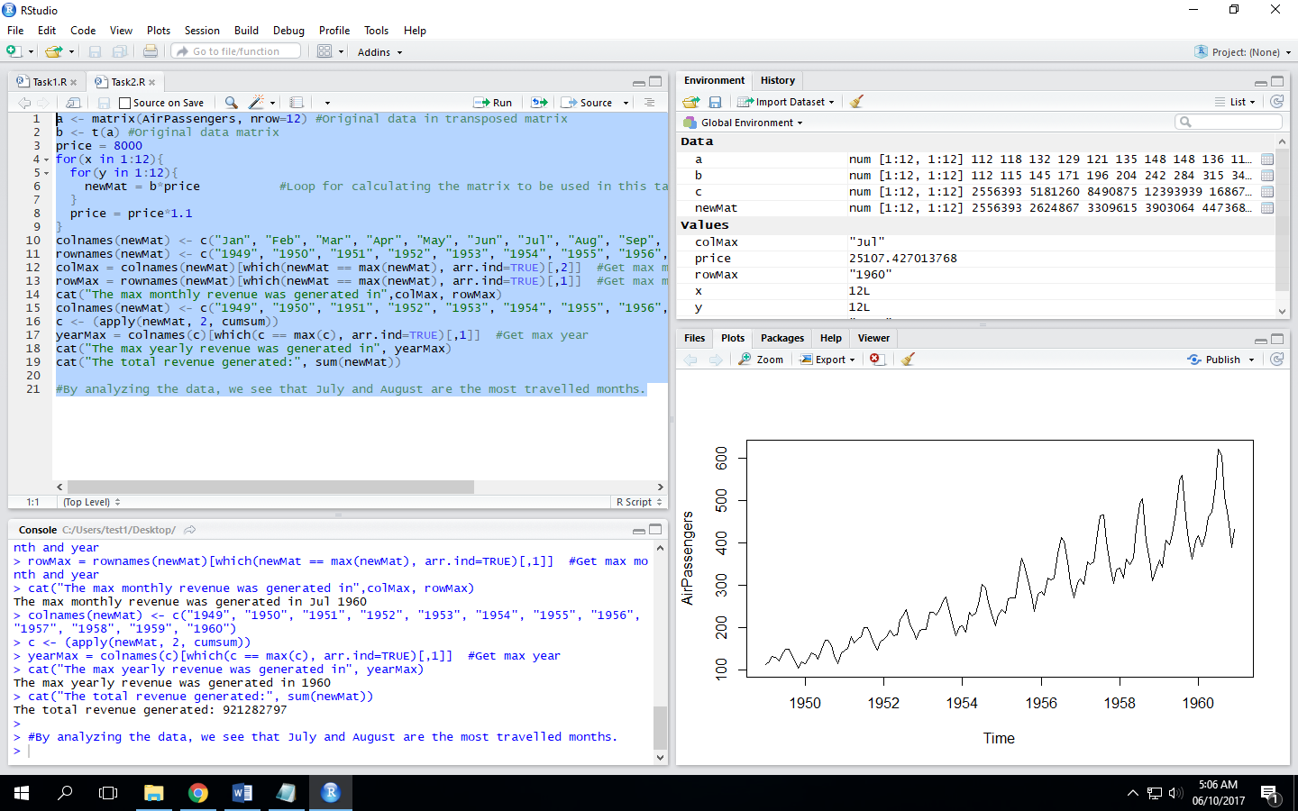

# Task 3:

By analyzing the data, we see that July and August are the most travelled months.